## **Task to Create the Full name field:**

**Prompt**

“Add Full name field alone in sign up page add the UI alone without change any of the other feature”

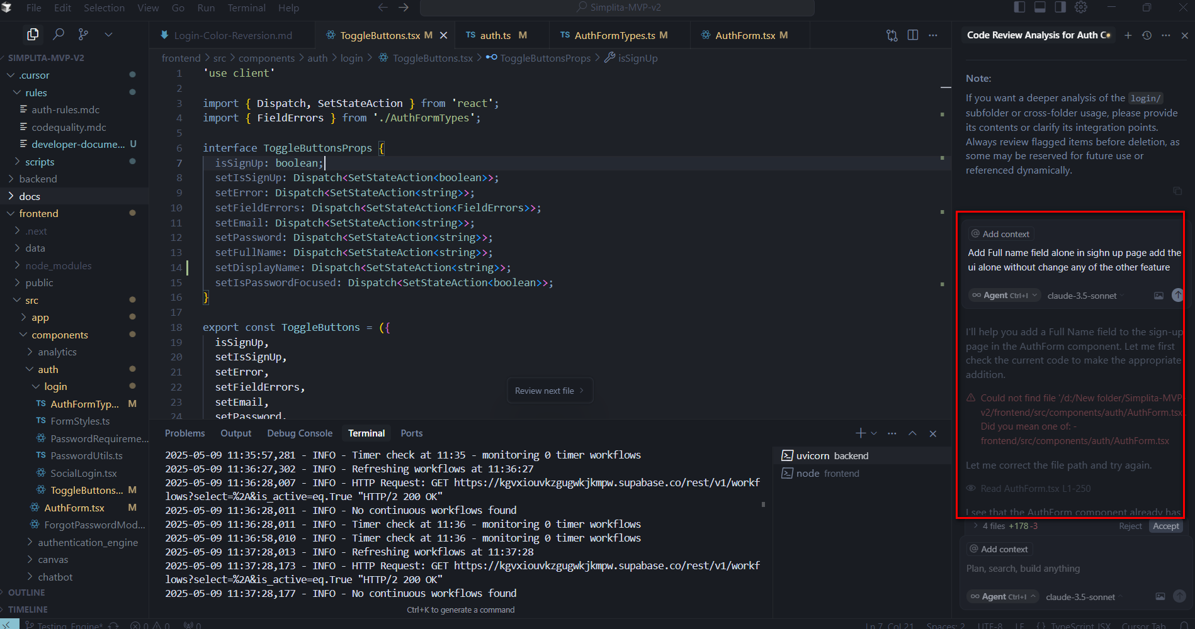

## **Prompt Used to create a doc:**

**Please generate the Dev Doc for my last feature in “Add full name field” doc**

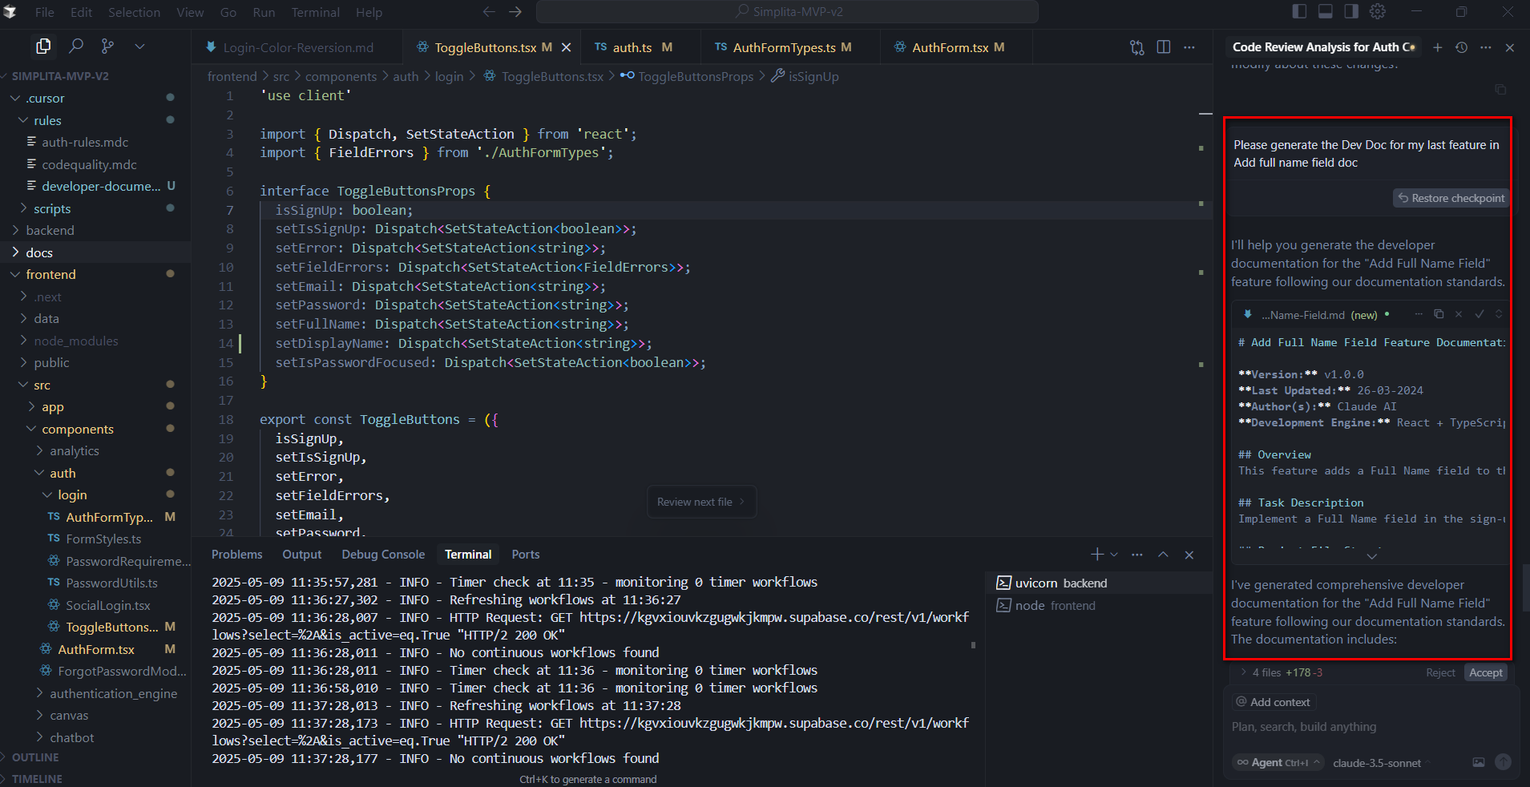

**Dev Documentation:**

The cursor created doc is attached here



